List copying in python:

It is a common mistake that many python developer do.

Whenever we need to copy a list to another variable the most commonly method we do is doing b=a. so that all the values in a will also be available in b.

When we run this code, we see that the indent behaviour of both is same.

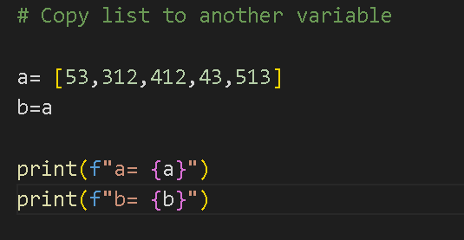

Output:



but actually they are not same. Let see why they are not same.

If i append a value in a, it will come in last of the list and then again if I use print statement we see that i add in a but it also added in b.

It is an intended behaviour, but sometime new developers don’t know about it. The reason behind is that, whenever we make a list and print it’s id (id gives a unique reference to a value), we can see that the id of a is present at the reference stored at ___ and also the id of b is also present at the reference stored at ___.

The reason is that, if the id of a and b is same and if you make some changes through a. It means we made changes in that id like (append or remove)